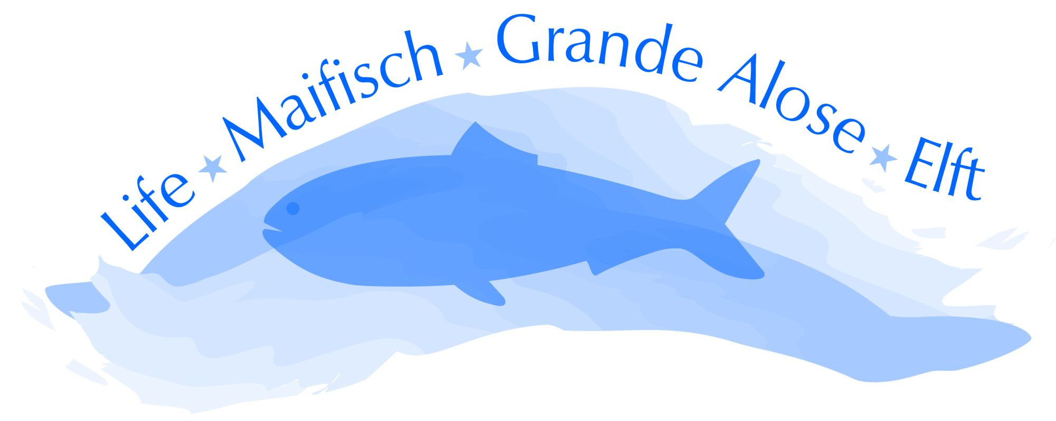
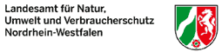
International Workshop
on the Restoration of Fish Populations




1-4 September 2009
Düsseldorf, Germany

Registration Form

Personal Details
SURNAME
FIRST NAME
TITLE
ORGANISATION
POSITION / JOB TITLE
ADDRESS

COUNTRY
TELEPHONE (inc. National code)
FAX (inc. National code)
EMAIL
Accompanying person? ⁺ | yes no
Name of accompanying person
Special dietary requirements (e.g. vegetarian)
Type of presentation (oral/poster) | oral poster
Title

Submission of a manuscript for the conference proceedings (yes/no) | yes no

+ Person who is not registering for the conference but is intending to travel and stay with you.

Conference Registration
cost
Full Conference Fee | € 180
Conference Fee - Early Bird Rate (until 15 March) | € 150
Full Conference Student Fee** | € 100
Daily Conference Fee (including lunch)
Tues 1st September | € 60 (€ 35 Student)  per day
Wed 2nd September | € 60 (€ 35 Student)  per day
Thurs 3rd September | € 60 (€ 35 Student)  per day
Conference Excursion | Yes/No? | yes no
Salmon Restoration in the Rhine River (1day) | € 30
Rhine delta excursion (2 days) | € 90
TOTAL REGISTRATION COST
* Each individual registering for the conference must complete a registration form
** Please indicate proof of student status e.g. NUS registration number

Payment

We request registration to be formally completed by full payment of the conference fee and the submission of the registration form. Registration is possible via mail, email or fax. Upon submission of your registration form, you will receive an invoice and complete payment information.
Payment should be made by bank transfer to LANUV NRW, a/c 41001256, “Fish Restoration 09 your name” at Sparkasse Attendorn-Lennestadt-Kirchhundem, routing number (BLZ) 46251630, international bank account number (IBAN) DE10 4625 1630 0041 0012 56, Bank Identifier Code (BIC) WELADED1ALK. Participants must cover all banking fees.

Cancellation of registration

dates cancellation fee
after 3 August 40% of conference fee
after 15 August 60% of conference fee
after 27 August 80% of conference fee

Accomodation
Accomodation can be booked via - Düsseldorf Marketing & Tourismus GmbH - Business Travel & Convention Service. A limited number of rooms are available in the FFFZ Hotel and Convention Center where the conference takes place. Availability of these rooms is on a first come, first served basis, so we recommend to book early. A large variety of hotels is available during the conference. We have listed a number of hotels which are in the segment 50-90 Euros and which are not too far away from the conference venue.
All hotel offers for Düsseldorf are online bookable.
Please check out the following link:
German: http://business.duesseldorf-tourismus.de/restoration_of_fish_populations.html
English: http://business.duesseldorf-tourismus.de/index.php?id=4329&L=1
INFORMATION Hotel Booking
Düsseldorf Marketing & Tourismus GmbH
- Business Travel & Convention Service -
Fon +49 (0) 211 / 17 20 2 -839
Fax +49 (0) 211 / 17 20 2 -3221
messe@dus-mt.de
www.duesseldorf-tourismus.de/business
We recommend e.g. the following hotels during your stay (August 31 – September 05/ 2009):
(1) Hotel FFFZ (Conference Venue)
------------------------------------------
Single room per night incl. breakfast from € 86 only
Brief description of the hotel: http://dd.nethotels.com/dd/english/fffz_duesseldorf/
The FFFZ Hotel and Convention Center offers its guests an individual space for work and meetings. It is the ideal place for conferences, conventions or overnight stays. Situated near the exhibition "Messe Duesseldorf" in a quiet, central and very convenient area as far as public transport goes our house combines a cultivated atmosphere with modern conference facilities. Surrounded by green lawns the hotel offers 47 rooms (exclusively non-smoker) with all the conveniences including one appartment and 3 rooms suitable for handicapped people.There are 9 conference rooms (20 – 250 square metres), a restaurant, the chapel and an underground car park.
(2) Hotel Garni Cascade * * *
------------------------------------------
Single room per night incl. breakfast from € 81 only
Brief description of the hotel: http://dd.nethotels.com/dd/english/hotel_cascade/
Comfortable and cosy rooms with a personal touch enable you to relax. The rooms provide: colour TV, radio, telephone, mini-bar, hair-dryer in each bathroom. The convient location in the heart of the fair city Düsseldorf and on the outkirts of the old town make it the ideal starting point for business and leisures. The hotel garage ensures a comfortable arrival and departure. Located in a quite side-street our hotel-guarantees a recreative stay.
> Distance to the FFFZ: approx. 3 km <
(3) Hotel Am Spichernplatz * * *
---------------------------------------------
Single room per night incl. breakfast from € 54 only
Brief description of the hotel: http://dd.nethotels.com/dd/english/am_spichernplatz
How about a break at our cosy and hospitable yet fair priced hotel. There is a vault sauna and solarium for your relaxation at your disposal, plus our specialties restaurant "Symposion" awaiting you with delighting dishes. Discover the advantages of our "round the clock" service.
> Distance to the FFFZ: approx. 4 km <
(4) Hotel Garni Diplomat**
----------------------------------------------------
Single room per night incl. breakfast from € 69,50 only
Brief description of the hotel: http://dd.nethotels.com/dd/english/diplomat_duesseldorf
Established now for 25 years ago the Hotel Diplomat is a quality bed and breakfast hotel, and has the personal and attentive service management that ensures your expectations of your stay here will be reached. Located in the heart of Düsseldorf and only few Kilometres from the Altstadt (Old town) or the Exhibition centre, the Hotel Diplomat will offer you and your Guests a very comfortable and relaxed atmosphere.
> Distance to the FFFZ: approx. 4 km <
(5) Hotel Doria * * *
------------------------------------------
Single room per night incl. breakfast from € 69 only
Brief description of the hotel: http://dd.nethotels.com/dd/english/hotel_doria
Hotel Doria is perfectly located for you if you plan to visit a trade fare, attend a conference, or spend a weekend trip in a wonderful city. The high level of comfort, modern convenience, and the friendly and attentive staff will guarantee a pleasant stay. All rooms are modern, light, nicely furnished and quiet, with sound proof windows or a backyard view. Additionally, all rooms are equipped with: Private bathroom, desk, direct telephone, cable TV with international channels, free movie channel (Premiere TV), data port, cosmetic mirror and hairdryer, alarm-radio.
> Distance to the FFFZ: approx. 5 km

Please return the completed forms to:

Email: Peter.Beeck@wasserlauf-nrw.de with “CONFERENCE 2009 REGISTRATION” in the subject line

POST
Dr. Peter Beeck
Stiftung Wasserlauf
Geschäftsstelle EU Life Projekt Maifisch
Aquazoo Löbbecke Museum
Kaiserswerther Straße 380
40200 Düsseldorf
phone +49 (0)211 8996 160
fax +49 (0)211 8994493

